

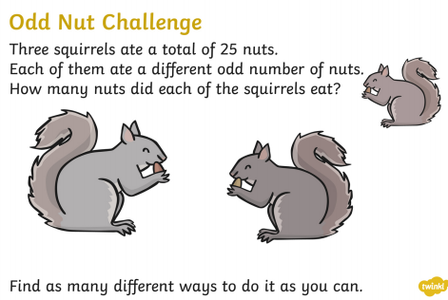

**Design a Tally Chart for your family’s favourite rainforest animals.**

**Design a Bar Chart for your family’s favourite rainforest animals.**

**Make a list of all the different countries in South America. Put them into a table to show what currency they use, their population and the size of the country in square kilometres. You can add any other facts you like.**

**Find out about an animal that lives in the rainforest and make a model or create a piece of art that shows it in its environment.**

A selection of complimentary side orders may also be offered throughout the term for you to take home with you.

**Write 10 facts about Brazil or any of the other countries in South America**

**Write a postcard home to your family from the rainforest.**

**Write a poem about the creatures and plant from the rainforest, using your senses.**

**Write a letter of complaint to the prime Minister about deforestation.**

**Write a non-chronological report about a rainforest animal- gorilla, anaconda, toucan, lemur or a tree frog.**

**Write a scientific account about the different layers of the rainforest, The understory, emergent layer, canopy layer and forest floor.**

**Imagine you are a rainforest guide and write a story about making a journey through the rainforest.**

**Year 4**

**TAKEAWAY HOMEWORK MENU**

Choose your homework each week from the menu below.

The Peri-ometer indicates the level of challenge in the homework.

You must attempt at least one Extra Hot task every half term.