Little Wandle- Letters and Sounds
EYFS Phonics Home Learning
Phase 2- Autumn 1 Week 2
Please support your child to practise and reinforce the phonemes and graphemes we are learning in school.
Phonemes we have focused on this week
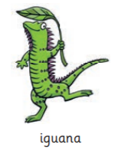 | 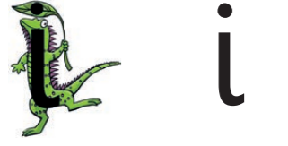 | 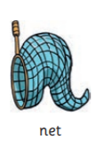 | 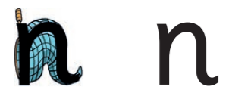
Pronuciation Phrase | Formation Phrase | Pronuciation Phrase | Formation Phrase
Pull your lips back and make the i sound at the back of your mouth i i i | Down the iguana’s body, then draw a dot [on the leaf] at the top. | Open your lips a bit, put your tongue behind your teeth and make the nnnnn sound nnnnn | Down the stick, up and over the net.
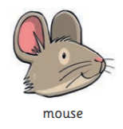 | 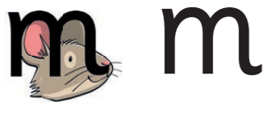 | 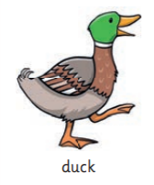 | 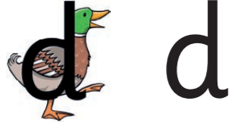
Pronuciation Phrase | Formation Phrase | Pronuciation Phrase | Formation Phrase
Put your lips together and make the mmmmm sound mmmmm | Down, up and over the mouse’s ears, then add a flick on the nose | Put your tongue to the top and front of your mouth and make a quick d sound d d d | Round the duck’s body, up to its head and down to its feet.

Words we are learning to oral blend: | Adult Led blending words:
s-a-t s-i-t t-a-p  s-i-p n-a-p p-a-n  m-a-n m-a-p m-a-t  d-i-p d-a-d s-a-d | sat sit tip  sat sit tip nap  sip nap pan man  man map mat dip

