Little Wandle- Letters and Sounds
EYFS Phonics Home Learning
Phase 2- Autumn 1 Week 1
Please support your child to practise and reinforce the phonemes and graphemes we are learning in school.
Phonemes we have focused on this week
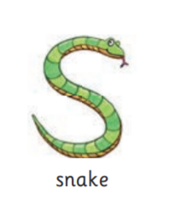 | 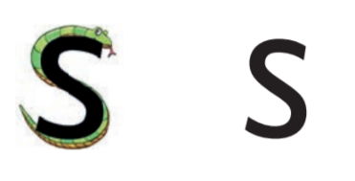 | 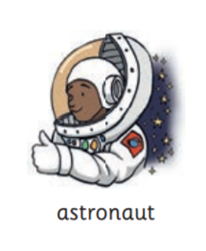 | 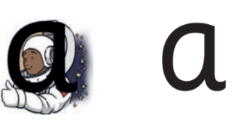
Pronuciation Phrase | Formation Phrase | Pronuciation Phrase | Formation Phrase
Show your teeth and and let the s hiss out ssssss ssssss | Under the snake’s chin, slide down and round its tail. | Open your mouth wide and make the a sound at the back of your mouth a a a | Around the astronaut’s helmet and down into space.
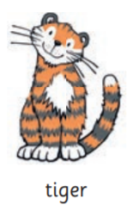 |  | 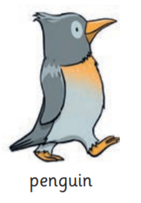 | 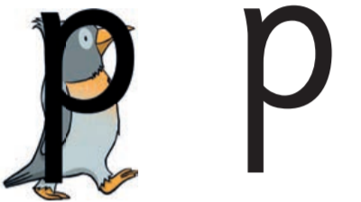
Pronuciation Phrase | Formation Phrase | Pronuciation Phrase | Formation Phrase
Open your lips; put the tip of your tongue behind your teeth and press t t t | From the tiger’s nose to its tail, then follow the stripe across the tiger. | Bring your lips together, push them open and say p p p | Down the penguin’s back, up and around its head.

Games we have played this week:
Can you touch your?  t-o-p  l-e-g  h-ea-d  ar-m | Can you do the actions?  n-o-d your head  c-l-a-p your hands  t-a-p your foot  r-u-b your tummy | What’s that noise? What sound does:  a d-u-ck make?  a f-r-o-g make?  a d-o-g make?  a s-n-ai-k (snake) make? | What is it?  p-i-n  a-n-t  s-u-n  t-a-p

